

Configuration of Microsoft SQL Server for DoubleClue Enterprise Management



# Introduction

This documentation is meant for administrators of MS SQL Server who would like to configure an MS SQL Server in order that it is able to communicate with DoubleClue Enterprise Management (DCEM).

Requirements:

* Installation of MS SQL Server 2014 or 2016
* Installation of the “Microsoft SQL Server Management Studio”
* Installation of the “Sql Server Configuration Manager”
* Administrator rights for the MS SQL Server

# Establishing a Connection with the Server

1. Start “Microsoft SQL Server Management Studio”.
2. Choose “SQL Server Authentication” in the field “Authentication”.
3. Use “sa” in the field “Login” and the password you chose during the installation of MS SQL Server.
4. Click on “Connect”.

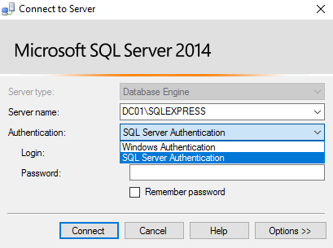

# Preparation of MS SQL Server

1. Start the “Sql Server Configuration Manager” **as an administartor**.
2. Unfold the item “SQL Server Network Configuration” on the left-hand side.
3. Make sure that “TCP/IP” is activated.
4. Click on “TCP/IP” via right-hand click and choose “Properties”.

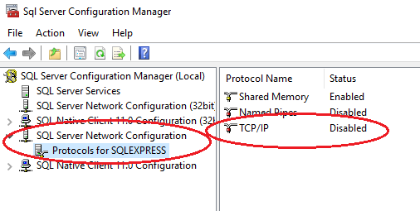

1. Select the tab “IP Addresses” in the upper menu bar.

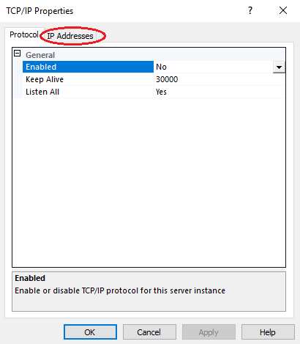

1. Scroll down to “IPAII”.
2. Make sure that the “TCP Port” at “IPAll” is set to “1433”.
3. Restart the MS SQL service.

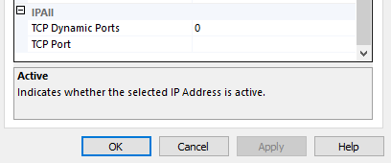

# DCEM Setup

1. Use the DoubleClue Windows Installer or go to the dircetory of your DCEM installation and open the folder “bat”. Execute the file “runSetup.bat”.

The configuration will automatically start in your default browser.

1. Select “MS SQL Server” in the field “Type”. Use “sa” as “Administrator Name” and as “Administrator Password” the password you chose during the installation of MS SQL Server.
2. Click on “Save” and then on “Next” to proceed with the next step.

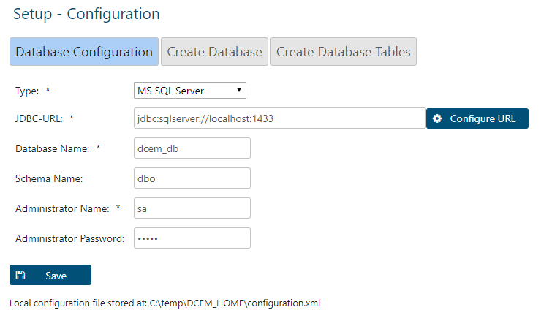

1. Use “sa” as “Database-Administrator Name” and as “Database-Administrator Password” the password you chose during the installation of MS SQL Server.
2. Click on “Create Database” and then on “Next” to proceed with the next step.

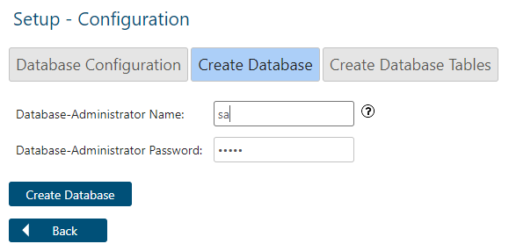

1. Use “sa” as “Create-Tables Administrator Name” and as “Create-Tables Administrator Password” the password you chose during the installation of MS SQL Server.
2. As “Super Administrator Password”, select a password with which you would like to log in to DCEM as a “SuperAdmin”. Confirm this password.
3. Click on “Create Tables”.

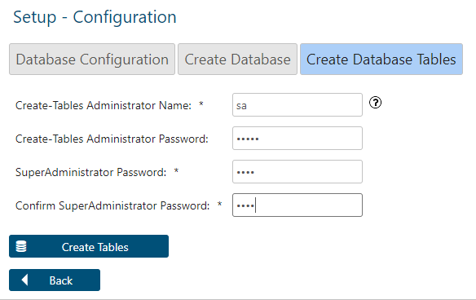

1. As soon as the database has been created, click on “Close Application”. Please note that your browser window will not close.

